**Database Management System Notes**

**DBMS Terminologies**

**Data:** Data is a representation to facts, concepts, or Instructions in a formalized manner suitable for communication, interpretation or processing by human or by automatic means

**1. DBMS: -**

A database-management system (DBMS) is a collection of interrelated data and

a set of programs to access those data. The primary goal of a DBMS is to provide a way to store and retrieve database information that is both convenient and efficient.

A database management system (DBMS) is a collection of programs that enables users to create and maintain a database. The DBMS is a general-purpose software system that facilitates the processes of defining, constructing, manipulating, and sharing databases among various users and applications.

**DBMS Services:**

1. Defining the Structure(DDL)

2. Manage the storage(DBA)

3. Manipulate a database (DML)

4. Manage database usage (DBA)

5. Monitor and analyse database usage(DBA)

DBMS examples include MySQL, PostgreSQL, Microsoft Access, SQL Server, FileMaker, Oracle, RDBMS, dBASE.

**2. Database: -**

A database is a collection of [data](javascript:openWindow('../../DatabaseTutorial/data.htm')) on a subject such as customers, products, or incident reports. A database can contain many elements and features. A database is a collection of [information](https://searchsqlserver.techtarget.com/definition/information) that is organized so that it can be easily accessed, managed and updated.

In database, data is organized into rows, columns and tables, and it is indexed to make it easier to find relevant information. Data gets updated, expanded and deleted as new information is added. Databases process workloads to create and update themselves, querying the data they contain and running applications against it.

**Database Applications are**

**Banking:** For customer information, accounts, loans, and banking transactions.

**Airlines:** For reservations and schedule information. Airlines were among the first to use databases in a geographically distributed manner.

**Sales:** For customer, product, and purchase information.

**Manufacturing:** For management of the supply chain and for tracking production of items in factories, inventories of items inwarehouses and stores, and orders for items.

**Human Resources:** For information about employees, salaries, payroll taxes, and benefits, and for generation of paychecks.

**3. Application program: -**

An application program accesses the database by sending queries or requests for data to the DBMS.

**4. Query: -**

A query is a statement requesting the retrieval of information. A query typically causes some data to be retrieved. The output data may be generated as results returned by Structured Query Language (SQL).

**5. Transaction: -**

A transaction, in the context of a database, is a logical unit that is independently executed for data retrieval or updates. A transaction may cause some data to be read and some data to be written into the database.

In relational databases, database transactions must be atomic, consistent, isolated and durable--summarized as the ACID acronym.

**6. Database Elements: -**

**Tables**

A database table is composed of records and fields that hold data. Tables are also called datasheets. Each table in a database holds data about a different, but related, subject.

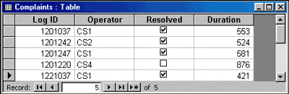

**Records**

Data is stored in records. A record is composed of fields and contains all the data about one particular person, company, or item in a database. In this database, a record contains the data for one customer support incident report. Records appear as rows in the database table.

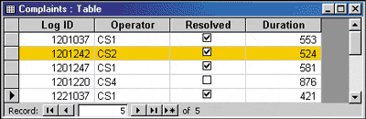

**Fields/ attribute**

A field is part of a record and contains a single piece of data for the subject of the record.

|  |  |
| --- | --- |
| Log ID | A number assigned to this customer support incident for identification purposes |
| Operator | The code for the customer support operator who handled this incident |
| Resolved | A check box to indicate whether the incident was resolved |
| Duration | The time in seconds the operator spent on this incident |

Fields appear as columns in a database table.

**Reports**

A report presents data in an attractive format and is especially suitable for printing. Reports can display data from tables or queries. All or selected fields can be included in a report. Data can be grouped or sorted and arranged in a variety of ways.

**Overview of File Systems**

The information can be either a conventional file processing system or a database system. In the conventional file processing system each and every subsystem of the information system will have its own set of files.

The concept of the conventional file processing system is shown in figure below which consists of three application/subsystems, namely Application X, Application Y and Application Z.

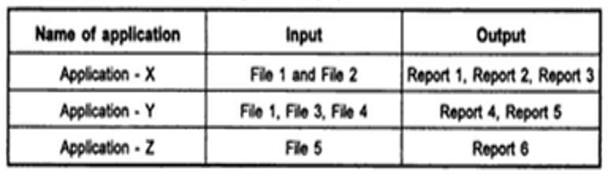

**Drawbacks of File System**

**Data redundancy and inconsistency**.

Since different programmers create the files and application programs over a long period, the various files are likely to have different structures and the programs may be written in several programming languages. Moreover, the same information may be duplicated in several files. For example, the address and phone number of particular customer may appear in a file that consists of personal information and in saving account records file also.

In addition, it may lead to data inconsistency; that is, the various copies of the same data may no longer agree. For example, a changed customer address may be reflected in personal information file, but not elsewhere in the system.

**Difficulty in accessing data**.

Conventional file processing environments do not allow needed data to be retrieved in a convenient and efficient manner. For e.g. suppose that bank officer needs to find out the names of all customers who live within the city’s 411027 zip code. The officer ask the data processing department to generate such a list. Since this request was not anticipated when the original system was designed, there is no application program on hand to meet it. However, there is no application program to generate the list of all customers.The bank officer has now two choices:

1) Either get the list of customers and extract the needed information manually.

2) Ask the data processing department to have a system programmer write the necessary application program.

Both alternatives are unsatisfactory.

**Data Isolation**

Since, data is scattered in various files, and files may be in different formats, it is difficult to write new application programs to retrieve appropriate data.

**Concurrent access anomalies**

In order to improve the overall performance of the system and obtain a faster response time many systems allow multiple users to update the data simultaneously.

Consider bank account A with $ 500 balance. If two customers withdraw funds from account A at the same time, the result of the concurrent executions may leave the account in an inconsistent state. The account may contain either $450 or $400, rather $350.

**Security**

Not every user of the database System should be able to access all the data. For e.g. in a banking system, payroll system person need to see only that part of the database that has information about the various bank employee. They do not need access to information about customer accounts. Since application programs added to the system in an adhoc manner, it is difficult to enforce such security constraints.

**Integrity Problems**

The data values stored in a database must satisfy certain types of consistency constraints. For e.g., the bank account may never fall below a prescribed amount (say $100). These constraints are enforced in the system by adding appropriate code in the various application programs.